Top Application Life Cycle & Developers Tool – Awarded to Stackify
Company’s application monitoring and performance tool hailed for its innovation

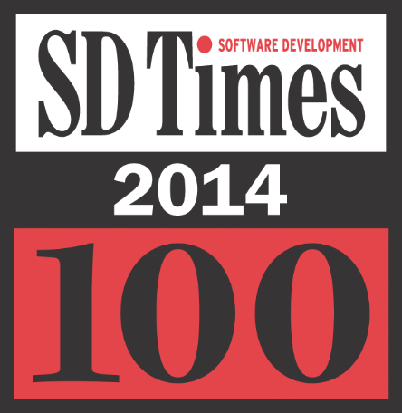
KANSAS CITY, MO, June 9th 2014, - Stackify, the developer of an innovative cloud based application performance monitoring , and troubleshooting platform, announced today that it has been selected to be part of SD Time’s Top 100 – a list of carefully selected industry’s top leaders, innovators, and influencers. The company is part of the top ten companies selected for the application life cycle and developer tools that includes agile, product-line management and performance monitoring.

“Building tools that really helped developers stick to the plan and avoid falling behind. Is not an easy task” said David Rubinstein chief editor for SD Times “When choosing the SD Times Top 100, we carefully considered each nominee’s products and services, thought leadership and reputation. We also listened for the “buzz”—how much attention and conversation we’ve heard around the company and its products and technologies—as a sign of leadership within the industry. Thanks to companies like Stackify, the future of software development is very bright!”

Stackify is the industry’s only platform, which combines comprehensive application monitoring with custom metrics, error tracking, and secure remote access. Stackify provides developers, operations and DevOps teams the ability to detect issues before they affect the business and shortens the time to resolution—thus improving users’ experience. The platform combines monitoring, errors, metrics, logs and secure remote access with the relevant context into one easy to use platform.

“We are helping software developers and operation managers to solve the problems that hurt their business. With Stackify they get application insights that helps them to improve their application performance monitoring and expedite application issue time-to-resolution”, said Matt Watson, CEO and founder of Stackify "We are honored to be selected for this award, as it further proves Stackify’s solution superiority in the application performance monitoring market."
About Stackify
Stackify provides software developers, operations and support managers with an innovative cloud based platform that allows them to monitor and troubleshoot their applications. Using Stackify, businesses get DevOps visibility and can easily and effectively detect and resolve application problems, ensuring their customers’ satisfaction. The platform combines monitoring, errors, metrics, logs and secure remote access with the relevant context in one platform. For more information visit www.stackify.com, try it for free, or follow Stackify on LinkedIn, Twitter
Media inquiries:
Irit Gillath
+1-816-888-5065
igillath@stackify.com

